

DBMS CIA

1740256



July 5, 2018

Jeevan KOSHY

**CONTENTS**

**SL NO. TITLE PAGE NO.**

|  |  |  |
| --- | --- | --- |
| 1 | Types of Databases, applications | 2 – 5 |
| 2 | Comparative study on 2 databases | 6 |
| 3 | References | 7 |

**TYPES OF DATABASES**

There are four structural types of database management systems:

1. **Hierarchical Databases**

In the Hierarchical Database Model, the records contain information about the groups of parent/child relationships, just like a tree structure. The structure implies that a record can have also a repeating information. In this structure, the data follows a series of records. It is a set of field values attached to it. It collects all records together as a record type. These record types are the equivalent of tables in the relational model, and with the individual records being the equivalent of rows.

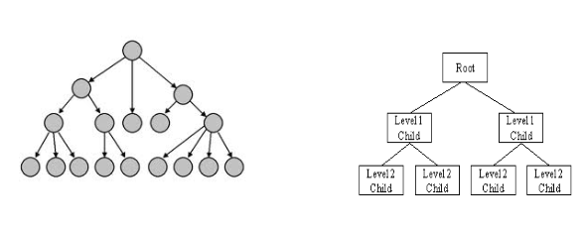

**Application**

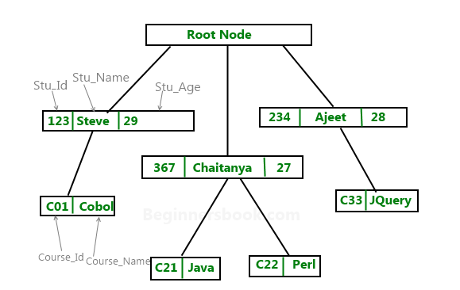

1. **Network Databases**

A network database is mainly used on a large digital computer. More connections can be made between different types of data, network databases are considered more efficient. It contains limitations when we have to use this kind of database. It is Similar to the hierarchical databases, network databases. Network databases are similar to hierarchical databases by also having a hierarchical structure. A network database looks more like a cobweb or interconnected network of records. The hierarchical model is a subset of the network model. However, instead of using a single-parent tree hierarchy, the network model uses set theory to provide a tree-like hierarchy with the exception that child tables were allowed to have more than one parent. It supports many-to-many relationships.

**Application**

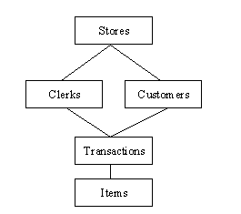

In the above example, the stores are the main database and then clerks and customers are the sub-sections of the store database. The transactions of the clerk and the customer can be categorised into one section. Among the transactions which happen – the items category can be placed.

This is one such example where network databases are used. There are many such applications like this.

1. **Relational Databases**

A relational database stores data in separate tables rather than putting all the data in one big storeroom. The database structures are organized into physical files optimized for speed. The logical model, with objects such as databases, tables, views, rows, and columns, offers a flexible programming environment. You set up rules governing the relationships between different data fields, such as one-to-one, one-to-many, unique, required or optional, and “pointers” between different tables. The database enforces these rules, so that with a well-designed database, your application never sees inconsistent, duplicate, orphan, out-of-date, or missing data. In relational databases, the relationship between data files is relational. Hierarchical and network databases require the user to pass a hierarchy in order to access needed data. These databases connect to the data in different files by using common data numbers or a key field. Data in relational databases is stored in different access control tables, each having a key field that mainly identifies each row. In the relational databases are more reliable than either the hierarchical or network database structures. In relational databases, tables or files filled up with data are called relations (tuples) designates a row or record, and columns are referred to as attributes or fields.

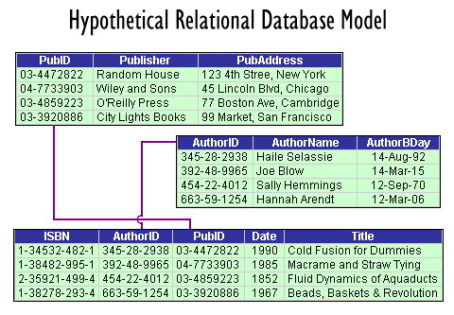

In the above example – we are linking the identity fields of 3 tables. From this, we make a relation to perform different operations on the tables.

1. **Object – Oriented Databases**

In this model we discuss the functionality of the object - oriented Programming. It takes more than storage of programming language objects. Object Oriented DBMS increase the semantics of the C++ and Java. It provides full-featured database programming capability, while containing native language compatibility. It adds the database functionality to object programming languages. This approach is the analogical of the application and database development into a constant data model and language environment. Applications require less code, use more natural data modelling, and code bases are easier to maintain. Object developers can write complete database applications with a decent amount of additional effort. The object-oriented database derivation is the integrity of object-oriented programming language systems and consistent systems. This database is basically applying the principles of Object Oriented programming.

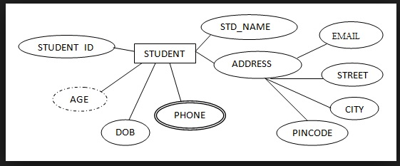

Here’s an application in the attributes of a student.

**COMPARITIVE STUDY**

A database is a structured collection of data. It may be anything from a simple shopping list to a picture gallery or the vast amounts of information in a corporate network. To add, access, and process data stored in a computer database, you need a database management system such as MySQL Server. Since computers are very good at handling large amounts of data, database management systems play a central role in computing, as standalone utilities, or as parts of other applications.

MS Excel is used very widely nowadays by everyone because it is very helpful and it helps in saving a lot of time. It is being used for so many years and it gets upgraded every year with new features. The most impressive thing about MS Excel is that it can be used anywhere for any kind of work. For example, it is used for billing, data management, analysis, inventory, finance, business tasks, complex calculations, etc. One can even do mathematical calculations using this and can also store important data in it in the form of charts or spreadsheets. MS Excel provides security to your files so that no one else can see your files or ruin them. With the help of MS Excel, you can keep your files password protected. MS Excel can be accessed from anywhere and everywhere. You can even work on MS Excel using mobile if you don’t have laptops. There are so many benefits of using MS Excel that it has become an inevitable part of lives of millions of people. MS Excel has numerous tools and features that make one’s work easy and saves one’s time also.

**MYSQL EXCEL**

|  |  |
| --- | --- |
| Database Management System | Analyses and stores data [DBMS] |
| Databases are relational | Recovers data, contains spreadsheets |
| Open Source | Fast, reliable, easy to use |
| Fast, reliable, easy to use | Mathematical Formulas |
| Works in client, server, embedded systems | Security |

**REFERENCES**

1. [**https://www.c-sharpcorner.com/UploadFile/65fc13/types-of-database-management-systems/**](https://www.c-sharpcorner.com/UploadFile/65fc13/types-of-database-management-systems/)
2. **https://beginnersbook.com/2015/04/hierarchical-model-in-dbms/**
3. [**https://www.google.co.in/url?sa=i&rct=j&q=&esrc=s&source=images&cd=&cad=rja&uact=8&ved=2ahUKEwjKobiq0IPcAhVMMI8KHduXDLkQjRx6BAgBEAU&url=http%3A%2F%2Fcriticaldensity.blogspot.com%2F2018%2F03%2Fdatabase-schemas.html&psig=AOvVaw1NyNjQxE7iATMZ2KpS4Ec7&ust=1530731224101593**](https://www.google.co.in/url?sa=i&rct=j&q=&esrc=s&source=images&cd=&cad=rja&uact=8&ved=2ahUKEwjKobiq0IPcAhVMMI8KHduXDLkQjRx6BAgBEAU&url=http%3A%2F%2Fcriticaldensity.blogspot.com%2F2018%2F03%2Fdatabase-schemas.html&psig=AOvVaw1NyNjQxE7iATMZ2KpS4Ec7&ust=1530731224101593)
4. [**https://dev.mysql.com/doc/refman/5.7/en/what-is-mysql.html**](https://dev.mysql.com/doc/refman/5.7/en/what-is-mysql.html)
5. [**https://magoosh.com/excel/10-best-uses-microsoft-excel/**](https://magoosh.com/excel/10-best-uses-microsoft-excel/)
6. **https://www.google.co.in/url?sa=i&rct=j&q=&esrc=s&source=images&cd=&cad=rja&uact=8&ved=2ahUKEwiE1aeA3IPcAhXFfSsKHWFYBi4QjRx6BAgBEAU&url=https%3A%2F%2Ftechexe.net%2Fdatabase-management-system-database-connection%2F&psig=AOvVaw3XhAfKePC6_pACycf6D9r1&ust=1530734347203511**

---------------------------------------------------------------------------------------------------------